**Question Number 1:**

**PROGRAM:**

#include <iostream>

using namespace std;

class Operators

{

public:

int A;

Operators *B;

Operators(int a=0)

{

A = a;

}

void *operator new(size_t A)

{

cout << "Enter the Size of the DMA Memory : ";

cin >> A; // new operator

Operators *ptr = new Operators[A];

return ptr;

}

Operators operator()(int a)

{

return A + a; // () operator

}

friend ostream& operator<<(ostream &a, Operators &b);

Operators *operator -> ()

{

return B; // -> operator

}

Operators operator %= (Operators a)

{

int b;

cout << "Enter value to take mod with : "; // %= operator

cin >> b;

return a.A %= b;

}

};

ostream& operator<<(ostream &a,Operators &b)

{

a << "Value of Variable is : " << b.A;

return a;

}

int main()

{

Operators *A = new Operators[2]; // using new opt

cout << endl;

Operators B; // using () opt

cout << B(2);

cout << endl;

Operators C(12); // using << opt

cout << C;

cout << endl;

Operators D(10); // using -> opt

cout << D->A;

cout << endl;

Operators E(12); // using %= opt

E%=12;

cout << endl << endl;

system("pause");

}

**Question Number 2:**

**PROGRAM:**

#include <iostream>

using namespace std;

class Matrix

{

public:

Matrix()

{

mat[2][2] = 0;

}

void get_data()

{

for (int i = 0; i < 2; i++)

{

for (int j = 0; j < 2; j++)

{

cout << "Enter the value of " << i + 1 << " row and " << j + 1 << " coloumn : ";

cin >> mat[i][j];

}

cout << endl;

}

}

void determinent()

{

cout << endl << "Determinent of the Entered Matrix !! "<<endl;

double temp;

temp = mat[0][0];

mat[0][0] = mat[1][1];

mat[1][1] = temp;

mat[0][1] = mat[0][1] * -1;

mat[1][0] = mat[1][0] * -1;

for (int i = 0; i < 2; i++)

{

for (int j = 0; j < 2; j++)

{

cout << " \t " << mat[i][j] << " ";

}

cout << endl;

}

}

;

void operator+(Matrix &A)

{

double temp[2][2];

for (int i = 0; i < 2; i++)

{

for (int j = 0; j < 2; j++)

{

temp[i][j] = mat[i][j] + A.mat[i][j];

}

}

for (int i = 0; i < 2; i++)

{

for (int j = 0; j < 2; j++)

{

cout << "\t" << temp[i][j] << " " ;

}

cout << endl;

}

}

private:

double mat[2][2];

};

int main()

{

Matrix A, B;

cout << "Entering Value For 1st Matrix !! " << endl;

A.get_data();

cout << endl << "Entering Value For 2nd Matrix !!" << endl;

B.get_data();

cout << endl << "Addition of 1st and 2nd Matrix !! " << endl;

A + B;

cout << endl << "Taking Determinent of 1st Matrix !!" << endl;

A.determinent();

cout << endl << "Taking Determinent of 2nd Matrix !!" << endl;

B.determinent();

cout << endl << endl;

system("pause");

}

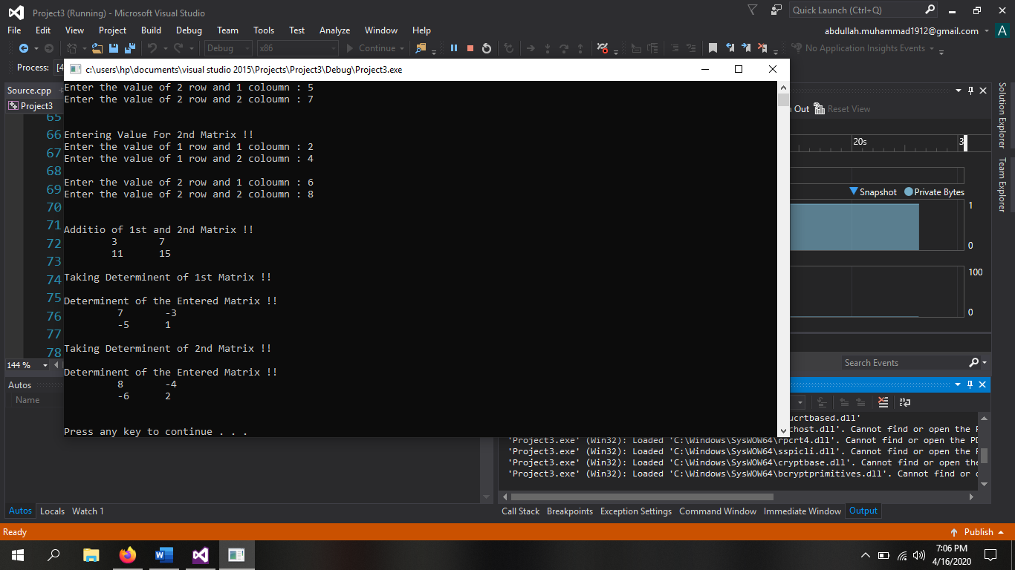

**Question Number 3:**

**PROGRAM:**

#include <iostream>

using namespace std;

class Counter

{

public:

int in, out;

Counter()

{

in = 0, out = 0;

}

void operator++()

{

++in;

}

void operator--(int)

{

out--;

}

void display()

{

cout << endl << "Total Persons that Entered the Bank are = " << in;

cout << endl << "Total Persons that Left the Bank are = " << out;

}

private:

};

int main()

{

Counter A;

int opt = 0;

while (opt != 3)

{

system("cls");

cout << "Press 1 if you want to Enter the Bank " << endl;

cout << "Press 2 if you want to Exit the Bank " << endl;

cout << "Press 3 if you want to Exit the Program " << endl;

cout << endl << "Option chosed : ";

cin >> opt;

switch (opt)

{

case 1:

{

++A.in;

cout << "Welcome to the Bank !" << endl << endl;

system("pause");

break;

}

case 2:

{

A.out--;

cout << "Good Bye! Have a Nice Day !" << endl << endl;

system("pause");

break;

}

case 3:

{

opt = 3;

break;

}

}

}

cout << endl << "Total Persons Information !!" << endl;

A.display();

cout << endl << endl;

system("pause");

}

**Question Number 4:**

**PROGRAM:**

#include <iostream>

using namespace std;

class Rectangle

{

public:

float length;

float width;

Rectangle()

{

length = 0; width = 0;

}

void getter()

{

cout << "Enter the Length of the Rectangle : ";

cin >> length;

cout << "Enter the Width of the Rectangle : ";

cin >> width;

}

void setter()

{

cout << endl << "Length of Rectangle is : " << length;

cout << endl << "Width of Rectangle is : " << width;

}

Rectangle operator+(Rectangle &A)

{

Rectangle temp;

temp.length = length + A.length;

temp.width = width + A.width;

return temp;

}

};

int main()

{

Rectangle A, B, C;

cout << "Enter Values For 1st Rectangle !!" << endl;

A.getter();

cout << endl <<"Enter Values For 2nd Rectangle !!" << endl;

B.getter();

cout << endl << "After Adding both Reactangles, we got a 3rd Rectangle !!" << endl;

C = A + B;

C.setter();

cout << endl << endl;

system("pause");

}

**Question Number 5:**

**PROGRAM:**

#include <iostream>

using namespace std;

class Rectangle

{

public:

float length;

float width;

float area;

Rectangle()

{

length = 0 , width = 0 , area =0;

}

void getter()

{

cout << "Enter the Length of the Rectangle : ";

cin >> length;

cout << "Enter the Width of the Rectangle : ";

cin >> width;

}

void setter()

{

cout << endl << "Length of Rectangle is : " << length;

cout << endl << "Width of Rectangle is : " << width;

}

void Area()

{

area = length*width;

cout << "Area of Rectangle is : " << area << endl;

}

Rectangle operator+(Rectangle &A)

{

Rectangle temp;

temp.length = length + A.length;

temp.width = width + A.width;

return temp;

}

bool operator<(Rectangle &A)

{

return area < A.area;

}

};

int main()

{

Rectangle A, B, C;

cout << "Enter Values For 1st Rectangle !!" << endl;

A.getter();

cout << endl <<"Enter Values For 2nd Rectangle !!" << endl;

B.getter();

cout << endl << "Area of 1st Rectangle !!" << endl;

A.Area();

cout << endl << "Area of 2nd Rectangle !!" << endl;

B.Area();

if (A < B)

cout << endl << "2nd Rectangle is Greater " << endl;

else if (B < A)

cout << endl << "1st Rectangle is Greater " << endl;

else

cout << endl << "Both Rectangles are Equal " << endl;

cout << endl << "After Adding both Reactangles, we got a 3rd Rectangle !!" << endl;

C = A + B;

C.setter();

cout << endl << endl;

system("pause");

}

**Question Number 6:**

**PROGRAM:**

#include <iostream>

using namespace std;

class Rational_Number

{

public:

float numenator;

float denomenator;

Rational_Number()

{

numenator = 0, denomenator = 0;

}

void get_data()

{

cout << "Enter the value of Numenator : ";

cin >> numenator;

cout << "Enter the value of Denomenator : ";

cin >> denomenator;

}

void show_data()

{

cout << endl <<"Value of Numenator is : " << numenator << endl;

cout << "Value of Denomenator is : " << denomenator << endl;

}

void add_data(Rational_Number A,Rational_Number B)

{

cout << endl << "Sum of Numenator of both Rational Number is " << A.numenator + B.numenator;

cout << endl << "Sum of Denomenator of both Rational Number is " << A.denomenator + B.denomenator << endl;

}

void operator + (Rational_Number &A)

{

float N, D;

N = numenator + A.numenator;

D = denomenator + A.denomenator;

cout << endl << "Numenator = " << N << endl;

cout << "Denomenator = " << D << endl;

cout << "Overall Sum after Solving = " << (numenator / denomenator) + (A.numenator / A.denomenator);

}

};

int main()

{

Rational_Number A, B;

cout << "Enter the values for 1st Rational Number " << endl;

A.get_data();

cout << endl << "Enter the values for 2nd Rational Number " << endl;

B.get_data();

cout << endl << "The values for 1st Rational Number !! " << endl;

A.show_data();

cout << endl << "The values for 2nd Rational Number !! " << endl;

B.show_data();

cout << endl << "Addition of Data of both Rational Numbers !!" << endl;

A.add_data(A, B);

cout << endl <<"Addition of Rational Numbers via Operator Overloading !!" << endl;

A + B;

cout << endl << endl;

system("pause");

}

